
Dhaka International University
Lab Report details:
Lab Report Topic : "Final Keyword in Java" & ‘’Override in Java”
Lab Report No : 03
Course Title : Object-Oriented Programming Languages
Course Code : 0613-202
Submitted By: | Submitted To:
S M Nabil Ausaf  Roll: 01  Reg No: CS-D-91-23-124492 | Prof. Md. Abdul Based

Date of Submission: 20 Nov 2024

Lab Report on "Final Keyword in Java"

Objective:
To understand how the final keyword is used in Java, more specifically declaring variables, methods, and classes, through implementation with a Java program.

Components Used:
1. Software: Any IDE or text editor of choice like Eclipse, IntelliJ IDEA, Notepad++ etcetera.
2. Compiler: JDK installed in the system.
3. Hardware: A computer which has an operational environment to execute Java programs.

Theory:
- final Keyword in Java: The final keyword declares constants or it prevents the structure, method, and class from being modified.
  - For variables, it means they are immutable; i.e., their value cannot be changed after initialization.
  - Applied to methods, final disallows overriding by subclasses.
  - Applied to classes, final disallows extension of that class.
2. Static Initialization Block:
- The static blocks get executed when the class is loaded into the memory and even before the creation of any object.
- Used to initialize static final variables.

3. Constructor:
- A special method that is mainly used to initialize the instance variables. The final variable which is not assigned during declaration must be initialized in constructor.

Code:

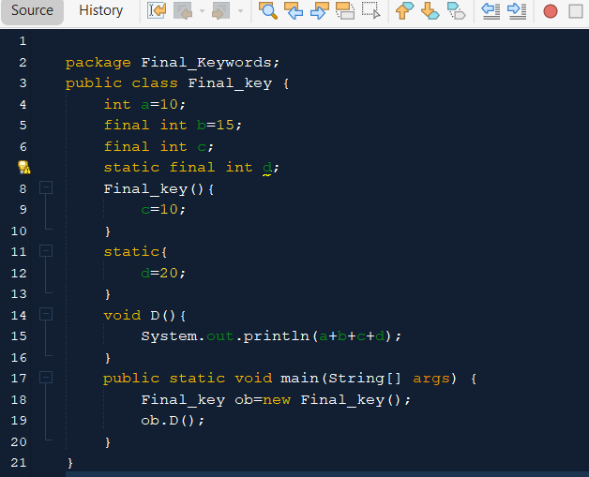

Procedure for Solution:
1. Define Class and Variables:
Declared four variables a, b, c, d using different combinations of final and static keywords to observe their behavior.
2. Initialization: Since c and d are declared as final but not initialized at the time of declaration, c was initialized using constructor and d using static block.
3. Implementation: A method D () has been written which calculates the sum of the variables and prints it.
4. Execution: Ran the program, compiled it to see if everything was logically correct, and also used final and static correctly.

Discussion:
1. Behavior of final Variables:
- Neither b nor c can be reassigned because they're final instance variables.
- The static final variable d was initialized with the static block once and was the same for all instances.
2. Static Block: The Static Block was used to initialize static variables before creating any object.
3. Role of Constructor: The constructor, further ensuring that the final variable c, which was not initialized, got initialized at object creation.
4.Output: Printing of sum of a, b, c, d did not show any errors, hence the logic is correctly implemented.
Output will be:
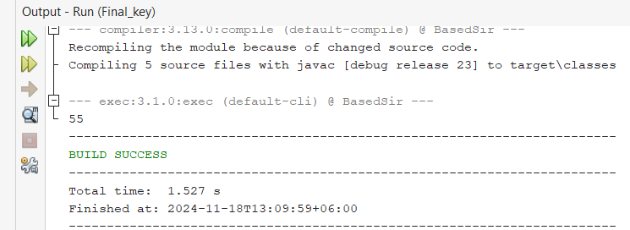
Conclusion:
1. Keyword final ensures that variables are immutable in nature.
2. Static block and constructor will be useful when immediate assignment of values is not possible to the final variables.
3. This lab provided practical exposure to handling constants and static initialization in Java.

Lab Report: Override in Java

Objective
The objective of this lab is to understand Override and how inheritance in Java works by developing a simple class hierarchy, in which a super class/base class Person and its sub class/derived class Teacher will be developed. The lab will also demonstrate method overriding and polymorphism in object-oriented programming.

Components Used
- Java Development Kit (JDK)
- Integrated Development Environment (IDE) such as Eclipse, IntelliJ IDEA, or any text editor with command-line execution.
- The knowledge of the Java programming language is required. Knowledge of object-oriented principles, such as inheritance and polymorphism is also needed.

Theory
Inheritance in object-oriented programming is a feature in which one class can inherit the properties/behaviors of another. This helps in code reusability and develops a relationship between classes.
- Super Class/Base Class: A class that is inherited from. In this example, the Person class is the base class.
- Sub Class/Derived Class: A class that is derived from another class. In this case, Teacher is a derived class of Person.
- Method Overriding: This is when a derived class offers a specific method definition where the method is already defined in its super class/base class.
- Polymorphism: This enables methods to do different things depending upon what object it is acting upon, even if the method is called the same.

Code
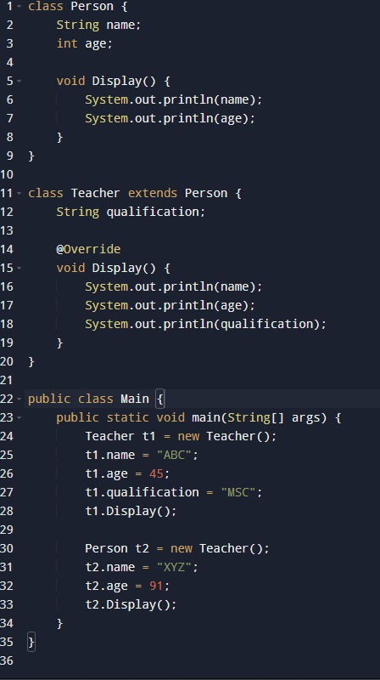
Problem Solving Procedure
- Define the Super Class/Base Class: Person class having name and age as attributes along with Display () method to print them.
- Create the Sub Class/Derived Class: Teacher class, which is derived from the Person class adding an extra attribute qualification and Override the Display () method of a base class to accommodate this new attribute.
- Instantiate objects: In the main method, instantiate a Teacher and set the attributes. Invoke the Display () method on both the Teacher object and the Person variable referring to a Teacher object.
- Compilation and Execution: Compile the Java program and execute it to see the output.
Output
When the provided Java code is compiled and executed, the following output is produced:

Discussion
This implementation shows the exact concept of inheritance. The Teacher class inherits properties from the Person class and, through the new added attribute, extends its functionality. An overridden method Display () allows the Teacher class to present some more information peculiar to teachers.
The output of this program demonstrates the proper display of attributes, first by the Teacher object, t1, and then by the Person variable, t2, referring to an instance of Teacher. This demonstrates how method overriding works and how polymorphism can have different behaviors depending on the actual object type.
Conclusion
This lab successfully demonstrated the principles of inheritance, method overriding, and polymorphism in Java. The extension of the Person class by Teacher was really effective to show the reusability of code and flexibility provided by OOP. The program produced the expected output, confirming that the implementation was correct. The exercise enhances understanding of how to use inheritance to develop more complex and functional software systems.

